**The ABQ 2020**

**About the ABQ**

|  |  |
| --- | --- |
| 1 | The Higher Level Leaving Certificate Business Paper consists of three sections. |
| 2 | Section 2 which is the Applied Business Question (ABQ) is a compulsory question. |
| 3 | The ABQ consists of a single practical Case Study Business Question – 80 marks are available, representing 20% of the total marks. |
| 4 | The text and questions of the ABQ are based on three specified units of the syllabus, out of a total of seven units, which alternate (change) on an annual basis.. |

**Methodology**

|  |
| --- |
| * This section requires you to **Name, Explain** and **Link** for each point. A high level of synthesis (i.e. combining different elements into the one answer) must be established and should therefore be done when you are fresh. **Evaluation** may be also required. |
| * In answering the questions on the ABQ candidates must **explain** and **make use of** relevant knowledge / theory (and understanding) gained in the subject while studying the course in addition to the relevant links from the ABQ. |
| * **Linking** of points made in your answer with the text by relevant quotes / phrases / statements from the ABQ is essential. It is recommended that you present the link / quote in a different colour ink. A DIFFERENT / SEPARATE link is required for each point of theory made within each part of the ABQ. A link will not be awarded marks without having the relevant theory attached. |
| * **Read the ABQ provided in full**before reading the questions, then go back and highlight the relevant points / links in the text. |
| * Present your answers to each part of the question in **point form** and be sure to link or quote from the text of the ABQ in your answer, even if you are not specifically requested to do so. |
| * The methodology that must be used can be seen by looking at the **structure** of the sample answers shown below. |

**ABQ Questions Leaving Cert 2020**

**Units 2/3/4**

**2005**

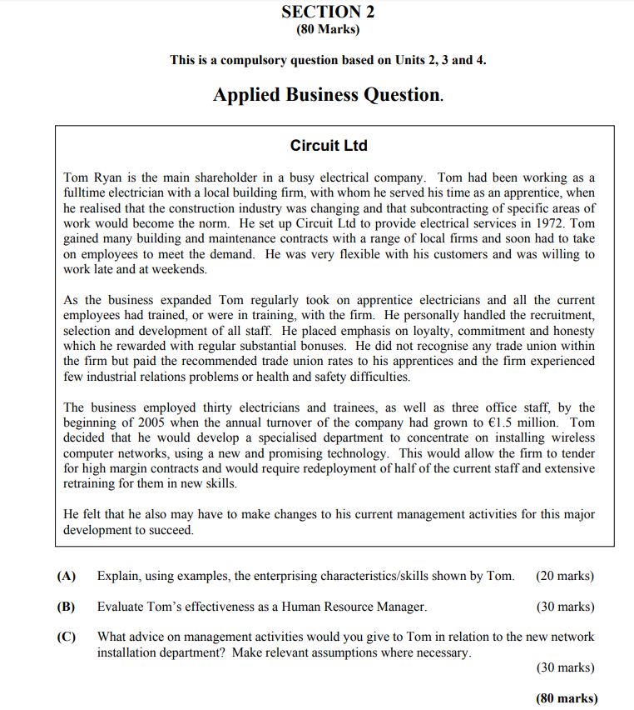

**2010**

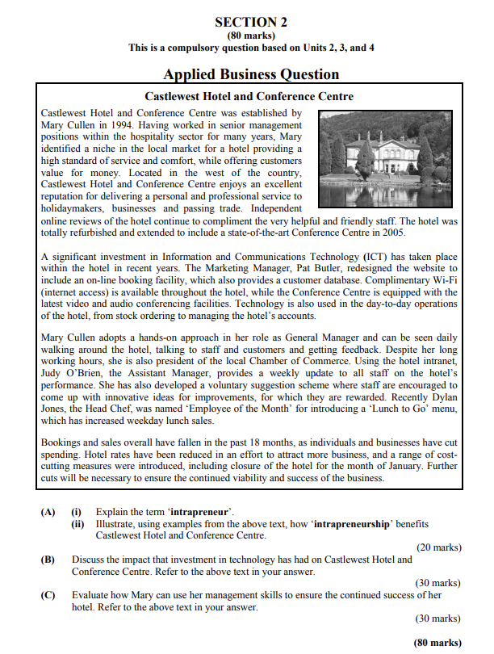

**2015**

